Breakfast Locations in San Mateo

Local
Our Place
742 Polhemus Rd
Off 92E and Hillsdale South
Celia’s Mexican
3190 Campus Drive

Laurelwood Shopping Center
Jamba Juice, McDonald's, Sonoma Bagel

Off 92E and El Camino
Sunshine Café (take El Camino North exit)
1750 S El Camino Real

Burger King
2817 S El Camino Real

Patio Coffee Shop
25 W 25th Ave

Mama Mia Cafe
19 W 25th Ave

Off 92E and Marina Blvd
Mimi’s Café (cross the overpass to Bridgepoint Mall)
2208 Bridgepointe Pkwy

Dinner Locations Driving from San Francisco

South San Francisco
Off 280S and Westborough Blvd (heading west)
Subway, Chinese, Vietnamese, Deli, Denny’s

San Bruno
Off 280S and San Bruno Ave. W (heading east)
Bayhill Shopping Center at San Bruno Ave W and 851 Cherry Ave
Vietnamese, Chinese, Sushi, Café Grillades Crepes, Pasta Pomodoro, Carl’s Junior, and Taco Bell

San Mateo
Local
Our Place
742 Polhemus Rd

Rainbow Pizza (and Greek food)
112 De Anza Blvd

Off 92E and South Hillsdale
Celia’s Mexican
3190 Campus Drive
Off 92E and South El Camino
Fresh Choice
1952 South El Camino Real

Hillsdale Mall Food Court
3723 S El Camino Real
The food court entrance is on the left side of the Sears building

The Counter
41 West Hillsdale Blvd

Le boulangerie
Sandwich Box Lunch
Single Serving
Your choice of a Le Boulanger gourmet sandwich, fresh fruit, premium chips, and a fresh baked cookie.
$9.95
Salad Box Lunch
Single Serving
Includes your choice of Le Boulanger's Classic Caesar, Primavera, or Sweet Strawberry Mango & Spinach salads. Includes sourdough bread, fruit, and a fresh baked cookie.

Assorted Sandwich Tray
Serves 10-12
A variey of Le Boulanger's gourmet sandwiches made on a selection of freshy baked breads.
$78.95

Fresh Fruit Bowl
Serves up to 12 People
An array of seasonal fruits.
$44.95

Assorted Dessert Tray
Serves 10-12 People
An assortment of Le Boulanger's fresh baked treats.
$29.95

Echte Laugenbrezn
German Pretzel
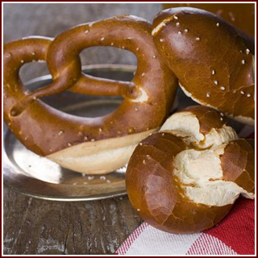
$1.70 usually, country sun naturals in PA sells for $1.50 right now
SausAGE $1.50 or adeles

