It is a dark and stormy night; you seek refuge in the warm light of the local Java Cavern, sheepishly hoping you won’t meet any co-workers.
You order a Grandissimo Double Latte with nuts, and settle down for a pleasant evening with the Saturday New York Times crossword, to be followed by another futile crack at the BBC’s Listener cryptic, and promptly lose yourself in the pizzazz and whimsy of Maleska’s whizbang editing; but then your mind wanders to the fuzzy patterns on the wall, and … zzzz .... You awake with a start when a key clicks in the door, and discover that the shop is closed, and you are alone, locked in.
After a few moments of panic, you notice something you never noticed in all the hours you have spent here: an elevator in a coffee house? In a one-story strip mall?? Curious and hopeful, you press the call button -- how odd: just one, unmarked, button! There seems to be no response, but just as you start to turn around to search for an unlocked exit, you hear a distant grinding sound, as of long-unused machinery, followed by a barely perceptible hum; the doors open suddenly with a metallic whoosh!, you step inside and hear the doors whoosh! behind you and you cannot see any seam where the doors closed. The cabin appears to be almost spherical in shape -- much bigger inside than you expected -- and brightly lit (but without a discernible source for the light) and you note that there are just two buttons inside, one embossed with ▲ and the other with ◄ ! You select a random button to push, the humming ceases, the doors whoosh! one more time, and you step out into… into a sunny day in a lush countryside, with a castle in the distance??!?
You see a path gaily festooned with flags, leading to the castle, and also a small path leading to the right… your puzzler expertise tells you that it’s important to take the right path … but which one is right?

If you choose to take the left path to the castle, turn to page 8
If you decide to take the right path, turn to page 27

Now the din of the outside world comes to a sudden halt as you step inside and close the solid oaken door behind you. A soft light fills the room illuminating some very fine reproductions of your favorite old masters, and soothing karmic-y music envelops you. There is a cheery fire going in the hearth, and two very inviting burnished leather club chairs to each side. You kick off your adventurer boots and slide into one of them. You are hardly surprised that all your favorite magazines are neatly laid out on the end table next to the chair. It’s almost too comfortable to make the effort to pour yourself a glass of fine VSOP from the ample cabinet close to hand, but you do make that effort. For the first time today, you feel more like a nabob than a shlub….

If you choose to stay here a bit longer, turn to page 2
If you decide to leave by the door to the East, turn to page 29
If you decide to leave by the door to the North West, turn to page 29 anyway

“Under your overpants!” you shout as soon as you think you are sufficiently far enough away to risk what you consider to be a witty riposte. Your self-satisfaction at having had this minor oratorical success buoys you as you stroll along the leafy tree-lined avenue, which seems to have lots of antique cars parked along the curb, your footsteps keeping staccato rhythm to the honking of horns and martial music oozing from hidden loudspeakers located every hundred meters or so along the leafy tree-, parkingmeter- and loudspeaker-lined avenue. “That music seems repetitive repetitive” you suddenly notice. What you do not notice is the company of jack-booted paramilitary chaps who break from the column parading down the street, and without a word, grab you by both arms and frog-march you, screaming all the while to passersby who seem oblivious to your predicament, to a stone building two blocks away, down a flight of stairs and along a corridor lined with cells from which low groans emanate, and toss you roughly into an unpadded cell which is furnished with a dim bulb, a cot and three hot plates, and more fellow victims than it was designed for.
“I’m an American citizen! You have no right!” you scream as the cell-door clangs shut (with a descriptive adverbal sound) behind you….

If you decide to try the cot, turn to page 29
If you decide to try the hot, turn to page 10

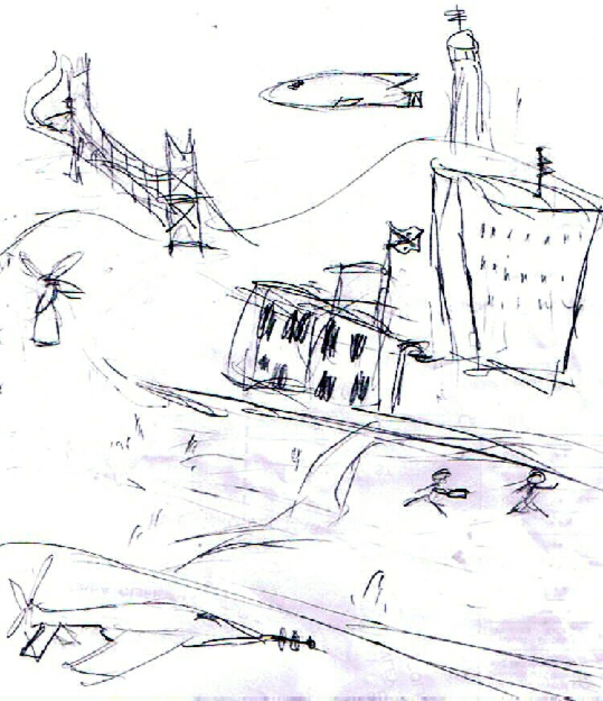

“Ah, that’s more like it”, you grin. You’re back in a familiar-looking urban area, standing on a hill by a tall fluted tower. Your tummy and meager dough suggest finding Golden Arches, but where in SF?

If you decide to acquire more cash first, go Panhandle in the Park, on page 36
If you decide to head straight to Oaktown for some McNuggets, hitchhike your way to page 7

“Bright sun and salt air beats being left to rot in a dungy castle” you mutter. As you step aboard the galleon, you remember how much you loved trips to Stinson Beach with your parents when you still under their cautious protection: if only they could see you now, you ruefully muse, they would probably regret all the times they encouraged you to take advantage of all the adventures that life had to offer….
“Step lively there, mate! We haven’t much time left in harrrbor, so if you’re just here to lubber about, avast with ye! Either stow your moth-eaten gear and starrrt belaying the bos’n’s porrrrt fo’c’s’le, or get lost. We can do without another useless nambywaist like you. But make sure that there Map is left on the table!”
He doesn’t look nearly as friendly as the travel brochures made him out to be; maybe this Treasure business is not such a good idea after all? How would you get it back to your own time/place/mythos?

If you decide to leave the ship while the going is good, turn to page 11
If you decide to hang tough and collect your share of the Treasure, turn to page 17

D’oh! You have successfully returned to your own time and country, unharmed but unenlightened. Congratulations…and have a good liff!

THE END!

Down the flag-bestrewn path you march. It gradually broadens to a virtual highway (unpaved, however) just before halting at a graveled circular field.
Many people, mostly dressed in rather shabby period-piece costumes to look like Medieval villagers, are milling around aimlessly amongst a few hastily constructed stands offering produce and refreshments. There are also a few chaps dressed as knights, making strange noises and pushing people around in a practiced officious manner. At the far side of the field is a short continuation of the road, crossing to a huge gate leading into the flag-bedecked castle. Along its walls are more folk in costume, brandishing swords or waving flags. The gate is, however, blocked by an imposing portcullis, just as in all the picture books. “Maybe I should have taken the path to the left after all”, you muse ruefully. “If only there were more signals.” You look around for something else to try…
…and spot a flagpost at one corner of the field, marking a pair of minor trails, and bearing only the unhelpful inscriptions “S” and SE”.

If you decide to take the trail to the South, turn to page 23
If you decide to take the trail to the Southeast, turn to page 20

“Gosh. What ridiculous dreams I’ve been having!” you mutter as you reach to the right side of your bed for your glasses … but they are not there where you usually park them just before turning out the lights; in fact, there is no right side of the bed, and in fact, there is no bed to even have sides, let alone a right side! Just the cold hard damp ground, and an un-optically-corrected vision of a monster that could exist only in the stupidest of dreams….

If you decide to get out of your non-existent bed, visit page 2

If you decide to pull the non-existent covers back over your possibly soon to be non-existent head, visit page 24

“My dear Grasshopper, it would appear that your journey has come to a suboptimal and sub-fortunate end in spite of your noble efforts”.
You look up as the door opens with a creak, and you see waddling toward you an enigmatically-smiling (or enigmatically-scowling?) gnomish figure like some Animatronic Yoda, complete with gnarled staff, unidentifiable faux-foreign accentuated English, slippers out of an outdated theater properties warehouse, long robe, and chartreuse hoodie. “I will give you another chance, however”, he says cheerfully.
“You have just made many wise decisions -- I will not fault you for any of them -- but perhaps you did not pay enough attention along the way; it is, after all, not the destination which makes the life, but it is the journey itself, my dearest Grasshopper! I am absolutely sure you will benefit from your experience and learn much that is new if you just pay attention to what the Power has been trying so hard to tell you.”
“Of course, if, and only if, you are very, very experienced, you may wish to take a totally different approach....”
“I guess I’ll give it another go!” you decide….

THE END?

Your head seems lighter than air, as you unexpectedly find yourself in a bar. It is a very strange bar indeed: lights, the colors of which are unlike anything you ever imagined, are flashing on, off, and everything in between, in time to syncopated sounds which sort of remind you of music heard in dreams! But it is the clientele! Not a human in the bunch! Barely even a humanoid, just, well, beings: brightly hued and scaly and viscous and fuzzy, with random numbers of head-like things, eye-like things, limb-like appendages, and wearing the most outlandish garb you have ever seen, right out of some far-fetched Sci-fi movie.
“I don’t seem to recall being invited to this party” you opine, but no one seems to be listening to you, or maybe they just don’t understand you; you really cannot quite make out anyone anything else is saying… that is, until the thing-behind-the-counter says, in unaccented American English “All right then, bud, what’ll it be? The usual, or you wanna try today’s special? I promise it’ll make you woozy.”

Try the special? Turn to page 28
Stick to the usual? Turn to page 22

“Everyone will be served in due course”, shouts a surly guard, with a tone of officiousness attributable to long practice or special training.
A large crowd of sketchily accoutered townsfolk is milling around the formidable portcullis, most of them holding small scraps of paper with notations like “A15”, “E72” or “C07” printed on them,
“Right, you there, where’s your waiting slip?” He seems to be looking right at you, so you try to escape his view by squatting under a tall lizard. No luck, he’s still coming and the crowd pushes you at him.
I’m for it now, you think, but he just asks “Register your wagon, or renew your trail tax?” and hands you a slip of grimy paper: “R1647”! Your neighbor cackles in a low whisper “you’ll be waitin’ here a day or thirty! Heh-heh!” You think quietly to yourself: “I may be caught up in some insane convention of the Society for Creative Anachronism, but even so this smacks way too much of life in postmodern times for my taste.”

If you choose to leave the waiting area, please turn to page 30
If you choose to wait for a while, please turn to page 34

Nobody here but us Chronospeleologists, you muse wryly after what seems like half-a-day of hiking. And not really too many of those, either, you muse even more wryly (perhaps ‘wrilier’ is better? Or is it wrylier?) … and just then, the trail makes a sudden twist (a lurch, really, you think wryly) and comes to a sudden end, blocked by a charming little cottage with sparkling walls, delicate gingerbread shutters, and a red-and-white striped lantern to the left of the glossy dark-brown door embossed with the legend “EAT ME”. Curious, you remark. You decide not to lick on, but merely to knock on, the door.
“Just a moment”, a foxy feminine voice coos. “I’ll just pop these cookies in the oven, and then…” Two shakes of a lamb’s tail later, and the door opens. To your surprise, the occupant (who seems to be alone in the cottage) is no fox at all, but a rather homely crone. “Do come in. I was just about to sit down to eat. I’ve prepared way too much for just little ol’ me. Wouldn’t you like to be part of the feast?” She is holding a copy of a book entitled “Manly Servings”, and certainly seems to have set out a man-sized spread. The rumbling in your stomach reminds you that even adventurers have to eat something. “Thank you ever so much, it all looks quite tempting!” you respond. “But I’ve just had quite a long and arduous journey; I’d like to wash up a bit first…” “By all means!” she cackles (gone is the foxy voice!) “Use either lavatory! And don’t forget to turn off the water.”

If you choose to use the lavatory marked S (for ‘Sexy Ladies’?), proceed to page 33
If you choose to use the lavatory marked E (for ‘Everyone Else’? ‘Elephants’?). proceed to page 27

Where you are standing has the appearance of a recently abandoned settlement: a couple of smoldering fires in hastily assembled stone circles, one or two discarded oilskins, some sandals with broken thongs rendering them presumably no longer serviceable. On closer look, you spy a number of very antique coins: brass, silver, even gold! You glance at the Treasure Map you have carefully concealed in your inner garment; perhaps you have entirely by chance stumbled upon the place marked with the big black X? Alas, no; there is no row of palm trees anywhere to be seen here, and it is most unlikely that there ever were any, since a nearby road sign suggests you are just outside Portland Oregon.
You decide it might be profitable to have a further look around to see what else of value has been left here. You pocket a few more coins, wishing you knew which ones were the rarer, and eventually deciding that only the gold ones were worth the weight in your pocket, or the wait before you could have them all assayed. After a few moments, you reach back into your pocket and discover only a gooey mess. Apparently those were just chocolate coins. You decide to sit down and have a good cry. You fall asleep, indifferent to the icy mist swirling around you.
You wake up, refreshed. Perhaps the gold you desire is better sought by mining rather than finding.

If you choose to prospect in the Golden State, take the Amtrak to page 5

If you figure the odds are better in Calgary, start walking to page 28

Definitely not a friendly-looking person, you muse as an extremely short and warty person barrels by you on your right side, pulling a heavy two-wheeled cart; you decide not to upbraid him for his rudeness after you notice the cargo of meat chunks hacked off without culinary rhyme or reason from a large variety of unknown creatures.
“Excuse me, but can you tell me where I am?” He ignores your desperate question and hurries off into the distance, naturally not even hearing your whispered follow-up: “…and can you tell me when I am?” You watch dejectedly as the cart and its master dwindle into the distance, then make a sudden lurch to the right, and finally fade from view. You proceed as fast as you can to where you last saw them, and discover that the trail has come to an abrupt end when you bang your fool head on a corner of a forbidding-looking stone wall! You see it is just possible to make your way along the wall in either direction, assuming your vision after that bump is still all right….

If you decide to proceed NW, turn to page 22
If you decide to proceed W, turn to page 12

“I can’t take much more of this”, you whimper, to no one in particular.

“Then don’t”, replies a small voice. You look down, and see no one in particular.

No one in particular continues: “Take matters into your own hands. Choose your own adventure, or at least your own exit!”

How about the exit to the S? It leads to page 10
Or perhaps you’d like the exit to the NE? It leads to page 28

“Come quick, come quick”, Anisette is yelling for you from the neighboring room.
“What is it this time, Ansie? Haven’t I given explicit instructions that I am not to be disturbed when I am working on cryptograms, or trying to figure out how to get back to my own time? This had better be very important!”
“Oh, yes Sir, it is! Very important. It’s the telephone, Sir. It’s for you! It’s…it’s the White House! And they insist on speaking only to you. Something about a job as first ever Special Envoy to the Galactic Federation!”
You reluctantly take the phone from your ever-gullible live-in. “Where is that pizza I order…Oh! Hello, Mr. President. I’m so sorry, I thought….What? Me? Yes, I see. Right away? But I’m right in the middle of an adven…. Yes, I see. Alright then, Mr. O, I’ll be right there, as soon as I pack my kit. It is OK to call you that, isn’t it, Mr. O?”

THE END!*

*…of this adventure, that is… somewhat prematurely…and the start of another, much more [thrilling/difficult/profitable/well-defined] one. Soon at your local appstore. Save up your credits!

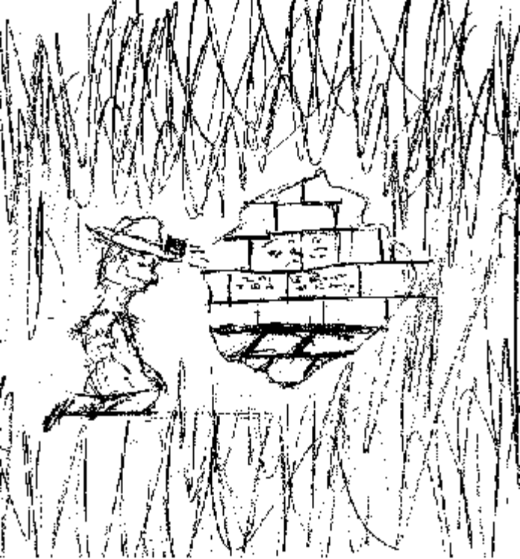

ozbbzy bioq p3r v2dsq qivyk qz o23r 232q2pb xpqs obpdk y2bb ei yzvi wkiowb z3 p bpqiv qv2x
Looks like some kind of code, you think as you stare in the dim light at the wall of the tomb. It was hard enough to bribe your way into this chamber, so sacred to the customs of the local tribespersons; you hadn’t the heart to trouble them for adequate lighting. But you are sure that the advice you got from the old gnome was true: in here you will find the answer to your quest. You strain your eyes to make out the smaller line chiseled underneath the first (presumed) message:
edoc ni nettirw deedni si egassem siht
Hmmm, you hmmm to yourself, it can’t be all that hard, can it? Hmmm …. EDOC…?

If you can’t crack the code, turn to page 3
If you can crack the code, turn to page 17

One hour later, and you have seen nothing of interest except an occasional magpie; you still have no idea where you are, where you are going, when you will get there, or when you will be when you do.

You are about to give up, when you come upon another trail junction, this one marked by an orange-and-white orienteering-style flag. As little as that is, at least it’s some indication of progress….

If you take the branch to the E, please turn to page 13
If, instead, you take the branch to the W, turn to page 15

Alone, you are in a room; there is a sturdy door in front and a less sturdy door, covered in foil and painted to match the floor, to the right.

They’re probably both locked, so I’ll need some sort of key to get out of here, you conclude presciently after thinking far too long over the matter. “If I were a key, where would I hide myself? Hmmmmmm.” you mutter as you continue your musings, and proceed to investigate your surroundings closely: there’s a rug on the floor (a likely spot), a grandfather clock ticking out a familiar-sounding syncopated melody, one of those Chinese puzzle-boxes next to the clock on the polished mantle. Also there is a gift box with a bright red ribbon around it, a table with two chairs and silverware set out as if for a romantic evening dinner, a bed with a smoking jacket laid out next to a Moroccan leather wallet and a keychain, someone’s collection of empty hot-sauce bottles, a bookcase with uniform-sized books bound in rich Moroccan leather, and… A KEYCHAIN???! You sheepishly unlock one of the doors at random, and see a dimly lit corridor, stretching into the distance in two directions….

If you go E, turn to page 14
If you go SE, turn to page 9

“Podden me, moddom, but I’m [urp!] not as crazy loaded as some thinkle peep I am” you say, recalling that it was good for a laugh in Prof. Frunt’s Speleology class, but it doesn’t have the right effect here. “That’s OK, the dames here are just a bunch of dogs!” you rationalize to yourself, even as you admit that they are not all dogs; some are cats and rabbits, and there’s even a very attractive hippo-like entity in a tutu over in the corner who won’t give you the time of day, let alone an hour or two for dancing : ( You think that perhaps it is time to move on to more productive activities, like trying to find your way back to reality -- or what used to be reality -- even if it means boredom with Prof. Frunt!
You fish a ten-credit piece out of your shirtpocket, plunk it down ostentatiously on the counter in front of the barkeep, mutter something about how things keep changing, or keep the change, or something, and step outside, to be accosted by a crab-cabbie holding the door open to his sputtering hover-kite: “Where to pal? Today’s specials are Southeast and Southwest!”

To fly Southwest, go to page 5
To fly Southeast, go to page 21

The first thing you hear as you enter the chamber is “Doctor, Doctor! They’re closing in! Doctooooo….”
This is also the last thing you hear as you enter the chamber.
You’ve just been X-term-in-a-ted by a Dalek.

THE END

(so sorry!)

“Ehhh. Now this is much better!” It’s another dream, you suppose. But at least it’s in pleasant surroundings!
You happily enjoy the cheerful carnival music and smells of cotton candy, deep-fried butter patties, and all the other comforting memories of Summers in the Park with Dad … except for the by-now expected sinister figure beckoning you from his tiny and shabby booth with a hand-written sign offering ‘Balloons, etc etera’ [sic!] and ‘Fortunes Told in Latin’, located between the fat lady and the BB-gun shooting gallery.
As you reluctantly approach him, you see that he is gazing intently at you with a pair of glass eyes, or at least some transparent substance unobstructed by artificial representations of pupils, and as you stare intently back into his ‘eyes’, you see that there is some text inscribed on the retinas! It appears to be just an eye chart, with letters of various sizes and orientations in a random arrangement; after a quick reminder to his hunchbacked assistant to keep blowing, he blinks and you look again: the text at the back of the socket now reads: “I’ll give you one of these nice balloons, if you promise to be a good child and pop it.”
“Gosh, thanks, Mister ... umm....”
“Just call me…” He pauses for effect… “sinister ... Mister Sinister….”

If you decide to pop the balloon and retrieve the message inside, turn your attention to page 26
If you decide to decode the mysterious writing on the balloon, turn your attention to page 25

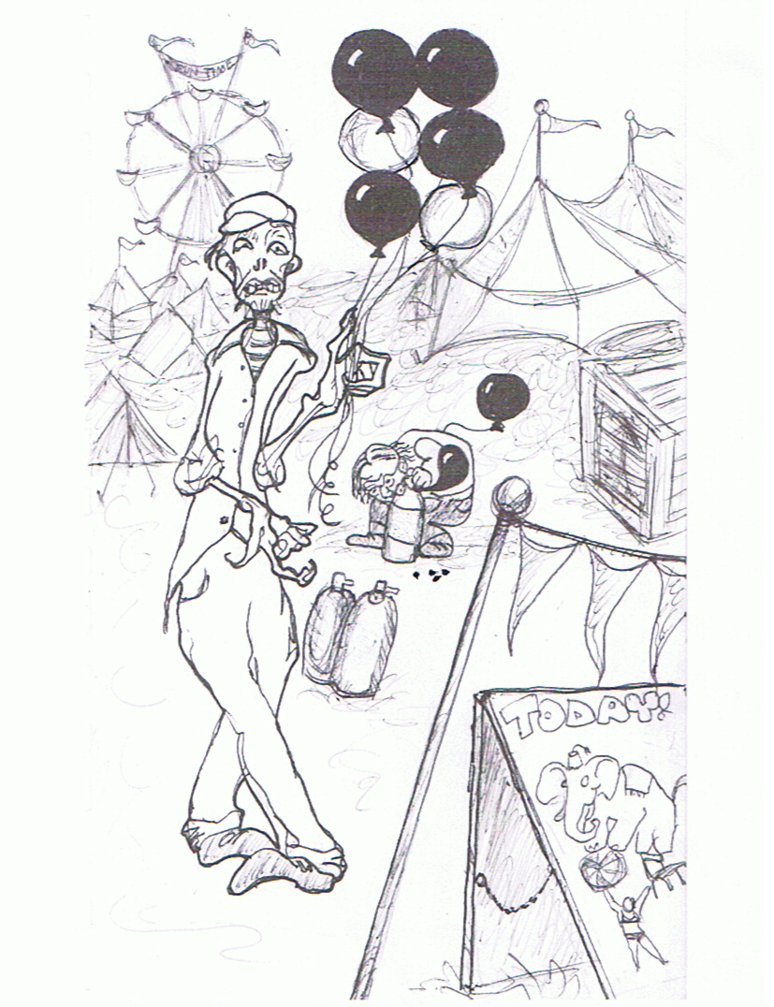

“’Never give rolling moss an odd overcall’: what kind of fortune, or clue, or moral is that?” you wonder offhandedly off the top of your head. You are by now strolling across a broad, weed-strewn field. There appears to be a building of some sort in the opposite side, with lilting music coming from the open door….and as you draw closer, you see that there is an erratically blinking ‘Stella ArtoisTM’ sign in the window of what can be nothing other than an old-fashioned taxi-dance hall! Not surprisingly, there is no velvet rope or bouncer at the door, so you step in and see that it is indeed a dance hall: a few couples are twirling gaily, but the vast majority of participants -- you notice that they are all dressed in shabby Hallowe’en costumes, mostly full-body suits of animals or super-heroes -- stand congregated along the four walls, waiting for some new arrival to offer an invitation to the dance.
“Why not give it whirl?” you decide, noticing a particularly curvaceous, if not exactly slim, lass in a tutu and Hippo costume giving you a ‘Je ne sais quois’ look …. “Hey, babe, how’z ‘bout a waltz?”, you gambit….
She responds with a sharp slap to your cheek: “Zat eez no way to talk to a laydee! You are … how you say zis? … so verry gauche!”

If you decide to slap her back (on her cheek, that is, not her back) (no, not that cheek, stop misinterpreting!) and leave through the W door of the dance hall, go to page 3
If you decide to turn the other cheek and leave via the door on the SE side of the dance hall, turn to page 16

Now’s not the time to encounter Knights who say Ni!!, so you decide it might be more prudent to stroll down the path away from the castle. It winds gently through the shrubberies, through a copse of tulgey wood, and then takes a sudden twist to the left just past the mimsy borogove. Too bad you left your Orienteer’s compass at home. Proceeding less confidently, you espy a shiny something that someone has left in the trail … you bend down to look at it … a spoon! You take a few more hesitant steps along the trail, and now there’s a fork in it. You wonder: “What a strange thing for someone to have left….”

Take the path to the W? Go to page 15
Take the path to the SW? Go to page 5

Back on the road again, you feel mightily relieved; if only you could find out where and/or when you are….

Your second question is answered by the sight of what appears to be a man in Roman Centurion dress, a considerable distance from you to the Northwest. A small array of tents is assembled behind him, but no other figures can be seen. “They must be in their tents. No wonder; must be crazy hot inside that figuratio unum*”, you observe, proud that you remember a bit from Frau Haarblau’s Latin class. You are about to take the opportunity to find out just how much you do remember, when you hear a mighty shout go up, and see, just steps away, a band of villagers evidently preparing for a luau of sorts: porculae* roasting on spits, leeks and pomae-terrarum* being tossed into a large cauldron.
“Hola*! Come on and join in the celebration!” An intimidating character in a striped jumpsuit and carrying a large stela* is ambling your way. His bulk grows more intimidating as he nears, but he looks quite amiable. “What’s going on here?” you ask, as you join him on the path back to the village. “Oh, we’re having the customary celebratory banquet. We rejoice over the defeat of our foes: less than two leagues to the Southwest you can visit the smoldering ruins of their outpost. The few we allowed to escape have set up a temporary camp beyond where you were standing; we’ll take care of them in the morning. In the meantime, let’s have a toast to Toutatis* together from the tureen and listen to the bard glorify our exploits.”
“This is more like I imagined adventuring would be!” you muse contentedly. After a full night of carousing, you fall into a deep sleep and awake late the next day, ready for new discoveries.

If you decide to see what happened to the temporary camp, turn to page 19
If you decide to visit the destroyed outpost, turn to page 21

*uniform
*boars
*crescent

*potatoes
*village-lingo for ‘aloha’

*menhir
*a pagan deity

Oh, no! It’s pitch black in here and…
You’ve just been eaten by a grue on level three.
Really now, you should have realized by this stage in your (now concluded) life that time travel requires much more serious efforts!

THE END

Seems you went through some sort of infinite loop or meta-mentometrico-whozis in your cautious attempt to retreat to familiar surroundings. And to think you had been so close to success just yesterpage. “Oh, dear, when will I ever see my beloved [Mother/Boyfriend/Girlfriend/Siamese Cat]* again?” you wail disconsolately. Now far from the proverbial familiar surroundings, you see another bloody castle. Well, you think resignedly, maybe this is to be the new familiar surroundings for me. You haven’t much time for such introspection, however, as you are suddenly hoisted on the shoulders of a cheering throng of villagers and carried to a nearby scene of carnage… and, at first sight, great gratitude and pulchritude! A delightful damsel, not in any apparent distress, rushes toward you with something no doubt intriguing to say….
“Yeah, you killed it. Fine and dandy! But here comes its mother, and she looks very angry!”

If you decide to beat a hasty retreat to the East, trun to page 33
If, instead, you decide to beat that same retreat, but in the opposite direction, run to page 26

*This is another choose-your-own option, naturally --- ed.

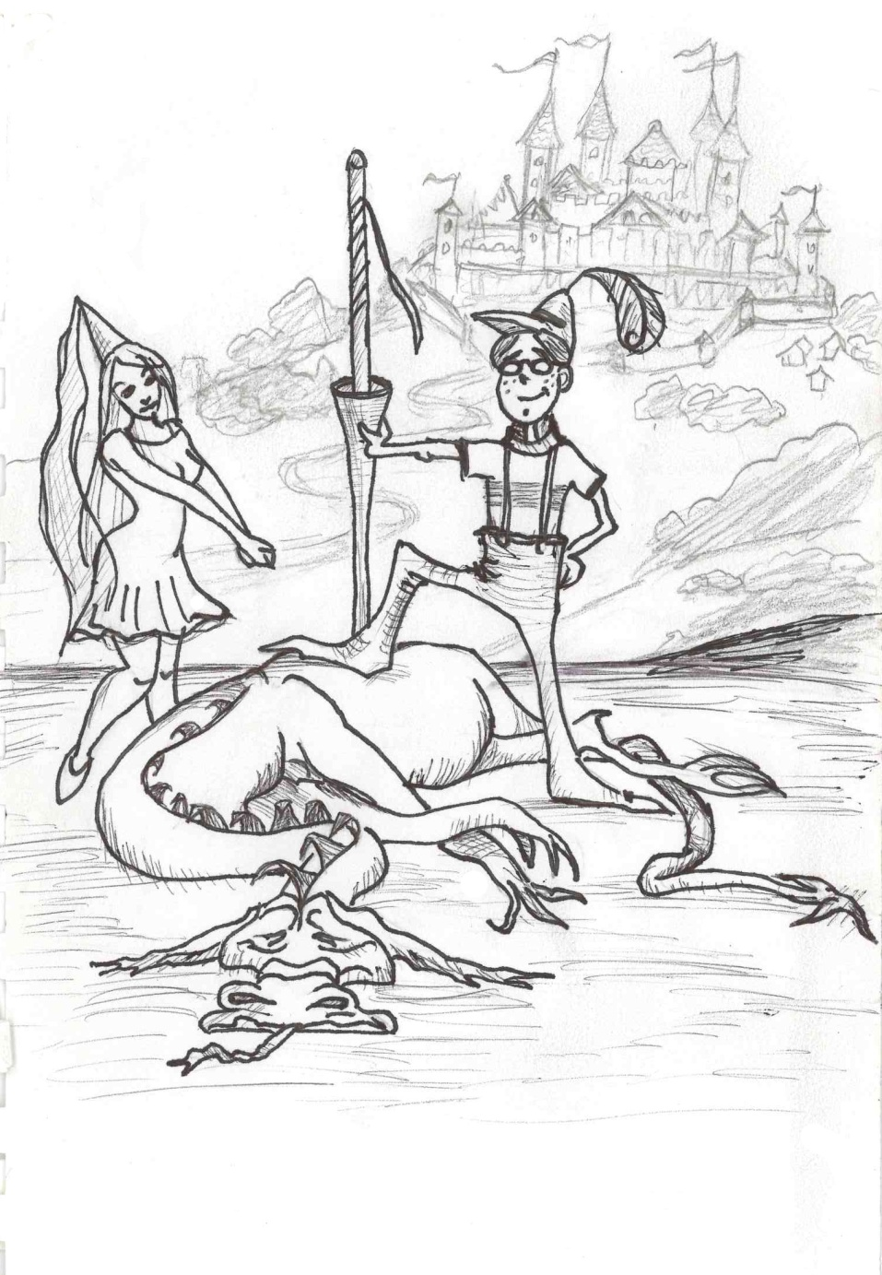

“How’d I ever get in here?” you wonder, “There are surely lots of exits, but no entrances!” You beyin to think that maybe you were born right here…”I’m back in the womb!” you soddenly exclaim.
“And I’m late.” You hear a voice behind you. You turn and see a ruther smartly dressed rabbit looking at his pocket calendar. “I’m late”, he repeats. “for a very important date.”
You are reliefed to realize you must be dreaming again. “Might as well play along with it” you think, and offer oloud: “Going to the Tea Party?”
“Who has time for politics?” the rabbit snaps. “I’ve got other eggs to fry. And to boil. And to paint. And I haven’t even started to look at the latest in bunnets….”
“Oh, I am sorry”, you hear yourself say, “I thought you were Tne White….”
“That’s the troudle with you humans these days. Always thinking, but never arriving at correct conclusians!” He continues, presunably to himself, “Now where can I have put that darn thing?”
“Would you mind terribly… ” you hesitate to interrupt his searches, “if I help you for a bet? We might have better luck together, and perhaps find a way out of this strange room, for I have no idea how I came to be hare….”
He looks irritased now. “Unless you are stilt a chile -- and it sure doesr’t look like it to me -- I don’t think you have the skills needed to help me. As for leaving, don’t wait for me. Feel free to leeve by either eggt, just so long as you leave, and don’t come back!”

If you choose the exit to the SE, turn to page 1
If the exit to the NW looks more helpful, turn to page 16
If neither one strikes your fancy, contact GC.

“That’s much better!” you sigh, relieved. The room (closet, really) has two exits.

If you choose to leave by the door marked W (for Wingchair) turn to page 2

If you choose to leave by the door marked SE (for Something Else), go to page 28

“X marks the spot!” you hear someone madly hawking; you turn to see a gaunt figure gesturing at you, as if he had important news to give. He is a strange figure in odd garb standing under a sign: “AA”.
He’s wearing a tattered three-cornered hat (mostly black, but with irregular crimson spots), has a black patch over his left eye, and from the way he teeters first one way and then the other, seems to be rather inebriated! Intrigued, you push your way through to the booth he has set up at the edge of the waiting area, and accost him with “Automob … erm … wagon Association? Or Alcoholics Anonymous, more likely?” “Eh, what’s that, lubber? Ah, ye means the sign, eh? I be representin’ the Adventurers Arrrrbitration council, and I be offerin’ ya this here fine and genuine Treasure Map! I’ve just got the one copy left, arrr ye gonna take it or not?”

You gratefully accept the Treasure Map, and turn to page 6
You courteously decline and rejoin the waiters on page 11

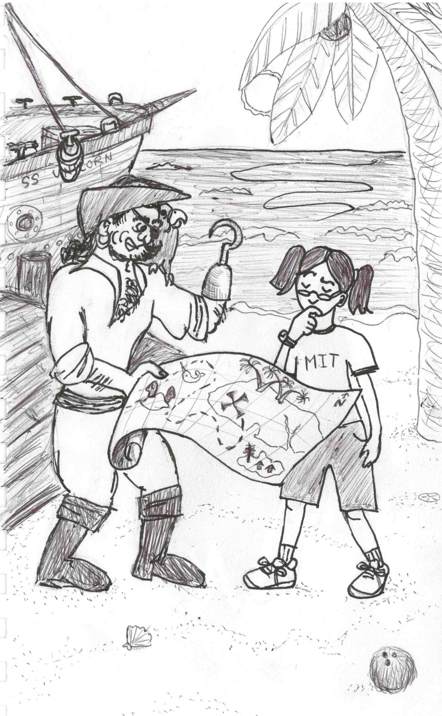

“Say, do have any spare …” you start to say. Unfortunately, your target is just a social worker who suggests you get the free soup at the Cliff House or register for work at the Golden Gate Bridge.

If you choose the soup, make your way to page 30
If you’re willing to look for work, trudge over to page 12

