SECTION 1

**Time – as long as it takes**

**12 Questions**

**1**

**1**

**1**

**1**

**Directions:** For each question in this section, select the best answer from among the choices given and fill in the corresponding oval on the answer sheet.

Each question below consists of a single word followed by five other words labeled A through E. Select the word that is most closely opposite in meaning to the original word.

**Example:**

PERIPHERAL

(A) mandatory

(B) central

(C) glorious

(D) lasting

(E) picturesque

A

B



C

D

E

**1.** LAVISH

(A) sparing

(B) unwashed

(C) vexed

(D) hostile

(E) nervous

**2.** MYOPIC

(A) sightless

(B) ethical

(C) intuitive

(D) smooth

(E) far-sighted

**3.** ASSUAGE

(A) irritate

(B) separate

(C) demonstrate

(D) delay

(E) meet

**4.** ILLICIT

(A) literate

(B) lawful

(C) private

(D) weary

(E) angry

**5.** COMMENCE

(A) send away

(B) exaggerate

(C) terminate

(D) graduate

(E) hold back

**6.** TACITURNITY

(A) irony

(B) futility

(C) tactlessness

(D) escalation

(E) wordiness

**7.** DEMISE

(A) birth

(B) residence

(C) arrival

(D) repetition

(E) act

**8.** PERFUNCTORY

(A) anxious

(B) irate

(C) individual

(D) thorough

(E) sinister

**GO ON TO THE NEXT PAGE**

**1**

**1**

**1**

**1**

**9.** DEFERENCE

(A) support

(B) disrespect

(C) vanity

(D) value

(E) postponement

**10.** REBUKE

(A) commend

(B) mature

(C) falsify

(D) matriculate

(E) assign

**STOP**

**If you finish before time is called, you may check your work on this section only. Do not turn to any other section in the test.**

**11.** MAUDLIN

(A) modish

(B) unimaginative

(C) unemotional

(D) outrageous

(E) exaggerated

**12.** FRUGALITY

(A) ire

(B) anxiety

(C) extravagance

(D) ripening

(E) timeliness

SECTION 2

**Time – as long as it takes**

**10 Questions**

**2**

**2**

**2**

**2**

**Directions:** For each question in this section, select the best answer from among the choices given and fill in the corresponding oval on the answer sheet.

Each question below consists of a related pair of words or phrases, followed by five pairs of words or phrases labeled A through E. Select the pair that best expresses a relationship similar to that expressed in the original pair.

**Example:**

CRUMB : BREAD ::

1. ounce : unit
2. splinter : wood
3. water : bucket
4. twine : rope
5. cream : butter

E

D

C

B



A

**13.** WOOD : ROTTEN ::

(A) soil : sandy

(B) bread : moldy

(C) paper : crumpled

(D) water : frozen

(E) glass : broken

**14.** SYMPHONY : INSTRUMENTALISTS ::

(A) play : actors

(B) jingle : rhymes

(C) poem : verses

(D) illusion : viewers

(E) palace : rooms

**15.** CUFF : WRIST ::

(A) cast : arm

(B) zipper : jacket

(C) belt : trousers

(D) mask : face

(E) collar : neck

**16.** FREIGHTER : CARGO ::

(A) suitcase : clothing

(B) elevator : building

(C) theater : audience

(D) ship : anchor

(E) supermarket : groceries

**17.** REPUGNANCE : DISTASTE ::

(A) confidence : insecurity

(B) trauma : recovery

(C) anger : forgiveness

(D) misfortune : pity

(E) horror : fear

**18.** SOMNOLENT : WAKEFUL ::

(A) graceful : clumsy

(B) benevolent : kind

(C) adamant : rigid

(D) envious : fortunate

(E) defiant : autocratic

**19.** INTERSECTION : STREETS ::

(A) crosswalk : lights

(B) junction : highways

(C) corner : block

(D) traffic : roads

(E) collision : automobiles

**20.** COURSE : SWERVE ::

(A) topic : digress

(B) consensus : agree

(C) signature : endorse

(D) arrival : depart

(E) ritual : observe

**GO ON TO THE NEXT PAGE**

**2**

**2**

**2**

**2**

**21.** SCENT : SKUNK ::

(A) tail : ferret

(B) mane : horse

(C) lungs : dolphin

(D) quills : porcupine

(E) plumage : cardinal

**STOP**

**If you finish before time is called, you may check your work on this section only. Do not turn to any other section in the test.**

**22.** RIDDLE : SOLUTION ::

(A) legend : key

(B) puzzle : skill

(C) joke : amusement

(D) question : answer

(E) problem : dilemma

**Directions:** For each question in this section, select the best answer from among the choices given and fill in the corresponding oval on the answer sheet.

SECTION 3

**Time – as long as it takes**

**9 Questions**

**3**

**3**

**3**

**3**

Each sentence below has one or two blanks, each blank indicating that something has been omitted. Beneath the sentence are five words or sets of words labeled A through E. Choose the word or set of words that, when inserted in the sentence, best fits the meaning of the sentence as a whole

**Example:**

Medieval kingdoms did not become constitutional republics overnight; on the contrary, the change was -------.

1. unpopular
2. gradual
3. unexpected
4. advantageous
5. sufficient

A

B



C

D

E

1. Marie Curie's more ------- achievements often ------- the contributions of her daughter, Irene Joliet-Curie, even though each woman won a Nobel Prize for Chemistry.
2. perplexing . . clarify
3. neglected . . invalidate
4. pioneering . . duplicate
5. famous . . overshadow
6. inspiring . . complement
7. Although they never referred to it -------, the two actors had a ------- agreement never to mention the film that had almost ended their careers.
8. vaguely . . clandestine
9. systematically . . presumptuous
10. longingly . . haphazard
11. oblique . . verbose
12. directly . . tacit
13. The critics reacted to the new book with enthusiasm; not one of their reviews was -------.
14. derogatory
15. professional
16. episodic
17. didactic
18. unsolicited
19. Oddly, a mere stranger managed to ------- Joanna's disappointment, while even her closest friends remained oblivious.
20. arouse
21. discredit
22. warrant
23. perceive
24. misrepresent
25. At bedtime the security blanket served the child as ------- with seemingly magical powers to ward off frightening phantasms.
26. a talisman
27. an incentive
28. an arsenal
29. a trademark
30. a harbinger
31. Despite his frequent shifting of allegiance, Johnson is not a flagrant -------, but he is nonetheless a striking specimen of moral -------.
32. novice . . excellence
33. opportunist . . equivocation
34. idealist . . ignorance
35. malefactor . . earnestness
36. paragon . . immaturity

**GO ON TO THE NEXT PAGE**

**3**

**3**

**3**

**3**

1. Scratching, though a useful self-remedy for an occasional itch, can ------- a problem by damaging the skin if performed too -------.
2. cure . . carefully
3. exacerbate . . vigorously
4. worsen . . refreshingly
5. clarify . . abrasively
6. exonerate . . violently
7. Crumbling masonry is ------- of the ------- that long exposure to the elements causes to architecture.
8. Evidence . . havoc
9. reflective . . uniformity
10. indicative . . amelioration
11. denial . . weathering
12. refutation . . damage

**STOP**

**If you finish before time is called, you may check your work on this section only. Do not turn to any other section in the test.**

1. Company employees were quite pleased with their efficient new work area because it provided an ideal climate ------- increased productivity.
2. stifled by
3. inimical to
4. shadowed by
5. conducive to
6. precipitated by

**4**

**4**

**4**

**4**

**Directions:** For each question in this section, select the best answer from among the choices given and fill in the corresponding oval on the answer sheet.

SECTION 4

**Time – as long as it takes**

**9 Questions**

**Questions 32-40 are based on the following passage.**

*45*

*70*

*65*

*55*

*60*

*75*

*50*

*This passage comes from the autobiography of a Black woman who grew up in Florida at the end of the nineteenth century.*

*30*

*25*

*20*

*15*

*10*

*5*

*Line*

Grown people know that they do not always know the why of things, and even if they think they know, they do not know where and how they got the proof. Hence the irritation they show when children keep on demanding to know if a thing is so and how the grown folks got the proof of it. It is so troublesome because it is disturbing to the pigeonhole way of life. It is upsetting because until the elders are pushed for an answer, they have never looked to see if it was so, nor how they came by what passes for proof to their acceptances of certain things as true. So, if telling their questioning young to run off and play does not suffice for an answer, a good swat on the child's bottom is held to be proof positive for anything from spelling "Constantinople" to why the sea is salt. It was told to the old folks and that had been enough for them, or to put it in Black idiom, nobody didn't tell 'em, but they heard. So there must be something wrong with a child that questions the gods of the pigeonhole.

I was always asking and making myself a crow in a pigeon's nest. It was hard on my family and surroundings, and they in turn were hard on me. I did not know then, as I know now, that people are prone to build a statue of the kind of person that it pleases them to be. And few people want to be forced to ask themselves, "What if there is no me like my statue?" The thing to do is to grab to broom of anger and drive off the beast of fear.

I was full of curiosity like many other children, and like them I was as unconscious of the sanctity of statuary as a flock of pigeons around a palace. I got few answers from other people, but I kept on asking, because I couldn't do anything else with my feelings.

Naturally, I felt like other children in that death, destruction, and other agonies were never meant to touch me. Things like that happened to other people, and no wonder. They were not like me and mine. Naturally, the world and the firmaments careened to one side a little so as not to inconvenience me. In fact, the universe went further than that – it was happy to break a few rules just to show me preferences.

*35*

For instance, for a long time I gloated over the happy secret that when I played outdoors in the moonlight the moon followed me, whichever way I ran. The moon was so happy when I came out to play that it ran shining and

*40*

shouting after me like a pretty puppy dog. The other children didn't count.

But, I was rudely shaken out of this when I confided my happy secret to Carrie Roberts, my chum. It was cruel. She not only scorned my claim, she said that the moon was paying me no mind at all. The moon, my own happy private-playing moon, was out in its play yard to race and play with her.

We disputed the matter with hot jealousy, and nothing would do but we must run a race to prove which one the moon was loving. First, we both ran a race side by side, but that proved nothing because we both contended that the moon was going that way on account of us. I just knew that the moon was there to be with me, but Carrie kept on saying that it was herself that the moon preferred. So then it came to me that we ought to run in opposite directions so that Carrie could come to her senses and realize the moon was mine. So we both stood with our backs to the gate, counted three, and tore out in opposite directions.

"Look! Look, Carrie!" I cried exultantly. "You see the moon is following me!:

"Ah, youse a tale-teller! You know it's chasing me."

So Carrie and I parted company, mad as we could be with each other. When the other children found out what the quarrel was about, they laughed it off. They told me the moon always followed them. The unfaithfulness of the moon hurt me deeply. My moon followed Carrie Roberts. My moon followed Matilda Clark and Julia Mosley, and Oscar and Teedy Miller. But after a while, I ceased to ache over the moon's many loves. I found comfort in the fact that though I was not the moon's exclusive friend, I was still among those who showed the moon which way to go. That was my earliest conscious hint that the world didn't tilt under my footfalls, nor careen over one-sided just to make me glad.

But no matter whether my probing made me happier or sadder, I kept on probing to know.

**32.** The discussion of statues in lines 20-25 expresses the narrator's view that most people

1. look forward to improving their lives
2. fear new experiences in the world
3. wish to challenge social mores
4. doubt their childhood fantasies
5. cling to self-promoting illusions

**GO ON TO THE NEXT PAGE**

**4**

**4**

**4**

**4**

**33.** According to the narrator, adults often respond to children's difficult questions by

1. rebuffing and punishing the children
2. changing the topic to more familiar subjects
3. referring the children to traditional oral tales
4. pretending to be too busy to answer
5. challenging the children to discover their own answers

**34.** In context, the phrase "pigeonhole way of life" (lines 6-7) refers to a

1. frustrated longing for more specialized knowledge
2. complacency about a particular way of thinking
3. compulsive desire to maintain family unity
4. recurrent tendency to ask petty questions
5. general tendency to avoid unpleasant truths

**35.** In line 51, "hot" most nearly means

1. lucky
2. spicy
3. extremely warm
4. ardent
5. electrically charged

**36.** The description of "the world and the firmaments" in lines 34-38 serves to emphasize the

1. sense of grandeur some adults enjoy
2. child's perception of an adult understanding
3. erroneous explanations put forth by adults
4. author's self-centered confidence as a child
5. subjects the author worried about as a child

**STOP**

**If you finish before time is called, you may check your work on this section only. Do not turn to any other section in the test.**

**37.** In line 32, "touch" most nearly means

1. press
2. rival
3. transfer
4. affect
5. tap

**38.** The "rules" mentioned in line 37 are

1. parental expectations
2. social customs
3. adult delusions
4. childhood rituals
5. natural laws

**39.** In lines 31-38, the narrator portrays children as

1. convinced adults do not understand them
2. unconscious of their own vulnerability
3. constantly seeking the meaning of life
4. impatient with adults' simplistic answers
5. frightened of the world around them

**40.** The phrase "happy to break a few rules" (line 37) helps to develop the narrator's

1. hope for an adult life happier than that of her childhood
2. childlike trust in her family and society
3. view of the world's random unpredictabiliy
4. childhood view of the world
5. strong identification with other children

SECTION 5

**Time – as long as it takes**

**13 Questions**

**5**

**5**

**5**

**5**

**Directions:** In this section solve each problem, using any available space on the page for scratchwork. Then decide which is the best of the choices given and fill in the corresponding oval on the answer sheet.

**Notes:**

1. All numbers used are real numbers.
2. Figures that accompany problems in this test are intended to provide information useful in solving the problems. They are drawn as accurately as possible EXCEPT when it is stated in a specific problem that the figure is not drawn to scale. All figures lie in a plane unless otherwise indicated.

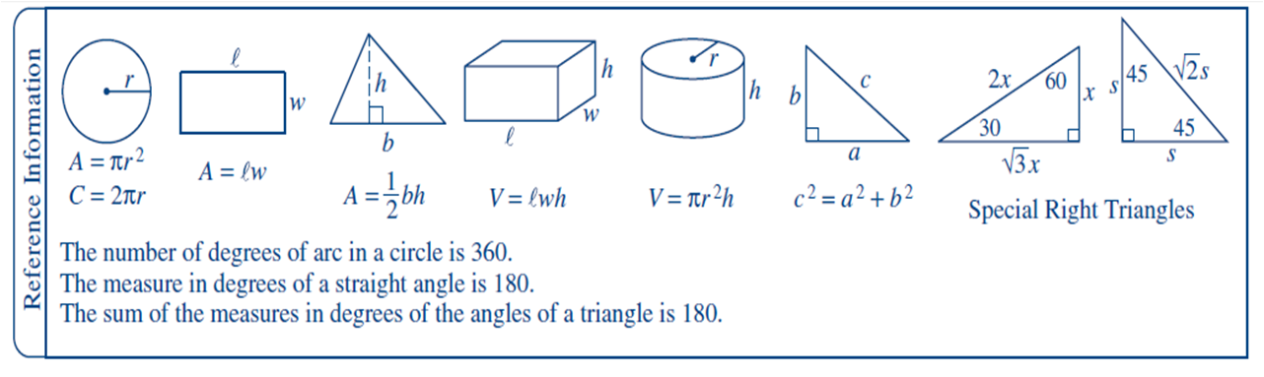

9 *x* + 2

3 3

=

1. If , what is the value of *x* ?
   1. – 5/9
   2. 7
   3. 3
   4. 7/3
   5. 25/3
2. In the *xy*-coordinate plane, the coordinates of three vertices of a rectangle are (1, 5), (5, 2), and (5, 5). What are the coordinates of the fourth vertex of the rectangle?
   1. (5, 7)
   2. (2, 5)
   3. (2, 1)
   4. (1, 7)
   5. (1, 2)

80, 80, 84, 85, 88, 92, 97, 98

1. The average (arithmetic mean) of the 8 numbers listed above is 88. Of the following, which pair of numbers could be removed from the list without changing the average?
   1. 80 and 97
   2. 84 and 92
   3. 80 and 98
   4. 85 and 92
   5. 84 and 97

**GO ON TO THE NEXT PAGE**

**5**

**5**

**5**

**5**

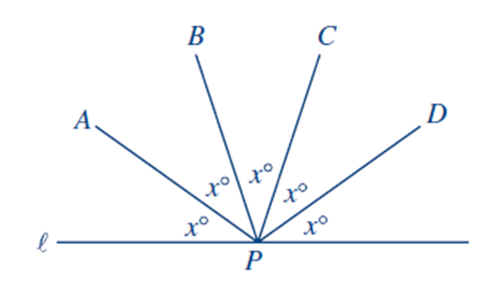

*l*

1. In the figure above point *P* is on line *l*. What is the value of *x* ?
   1. 15
   2. 36
   3. 35
   4. 30
   5. 26

4*K*8

3

*m*

=

1. In the equation above, *K* is a digit in the three-digit number *4K8*, and *m* is a positive integer. Which of the following could be the digit *K* ?
2. 1
3. 7
4. 5
5. 4
6. 3
7. Francis bought a stereo for *x* dollars and sold it at a 3 percent profit. Which of the following gives the amount of Francis' profit?
8. $0.03*x*
9. $0.07*x*
10. $0.30*x*
11. $0.70*x*
12. $0.97*x*
13. If *w* < *x* < *z* and *w*  < *y* < *z*, which of the following statements must be true?
14. *w* < *z*
15. *x* < *y*
16. *y* < *z*
17. I only
18. II only
19. III only
20. I and III only
21. I, II, and III
22. Three percent of 4,200 is equal to 6 percent of what number?
23. 8,400
24. 126
25. 252
26. 1,260
27. 2,100

**GO ON TO THE NEXT PAGE**

**5**

**5**

**5**

**5**

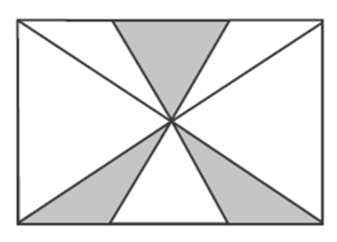

1. Four lines are drawn through the center of the rectangle shown above. What fraction of the area of the rectangle is shaded?
   1. 3/8
   2. 1/4
   3. 1/8
   4. 1/10
   5. 1/16

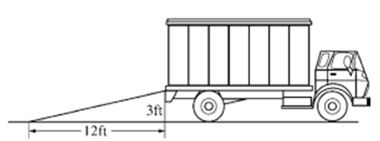

Note: Figure not drawn to scale.

1. The figure above shows a ramp that extends from level ground to the bed of a truck. What is the slope of the ramp?
2. 4
3. 3
4. 4/3
5. 1/3
6. 1/4

**STOP**

**If you finish before time is called, you may check your work on this section only. Do not turn to any other section in the test.**

{6, 2, 1, 3}

1. If *k* is a number so that the sum of *k* and any number in the set above is also in the set, what is the value of *k* ?
2. 5
3. 4
4. -1
5. 1
6. 0
7. How many positive integers less than 1,001 are divisible by either 2 or 5 or both?
8. 500
9. 400
10. 700
11. 540
12. 600
13. A group of 110 people is divided into 4 committees. If each committee contains at least 2 people, which of the following statements must be true?
14. Each committee has at least 4 people.
15. No 2 committees have the same number of people.
16. No committee has more than 100 people.
17. At least 1 committee has more than 25 people.
18. The largest committee has 3 more people than the smallest committee.

**6**

**6**

**6**

**6**

SECTION 6

**Time – as long as it takes**

**14 Questions**

**Directions:** In this section solve each problem, using any available space on the page for scratchwork. Then decide which is the best of the choices given and fill in the corresponding oval on the answer sheet.

Notes:

1. All numbers used are real numbers.
2. Figures that accompany problems in this test are intended to provide information useful in solving the problems. They are drawn as accurately as possible EXCEPT when it is stated in a specific problem that the figure is not drawn to scale. All figures lie in a plane unless otherwise indicated.



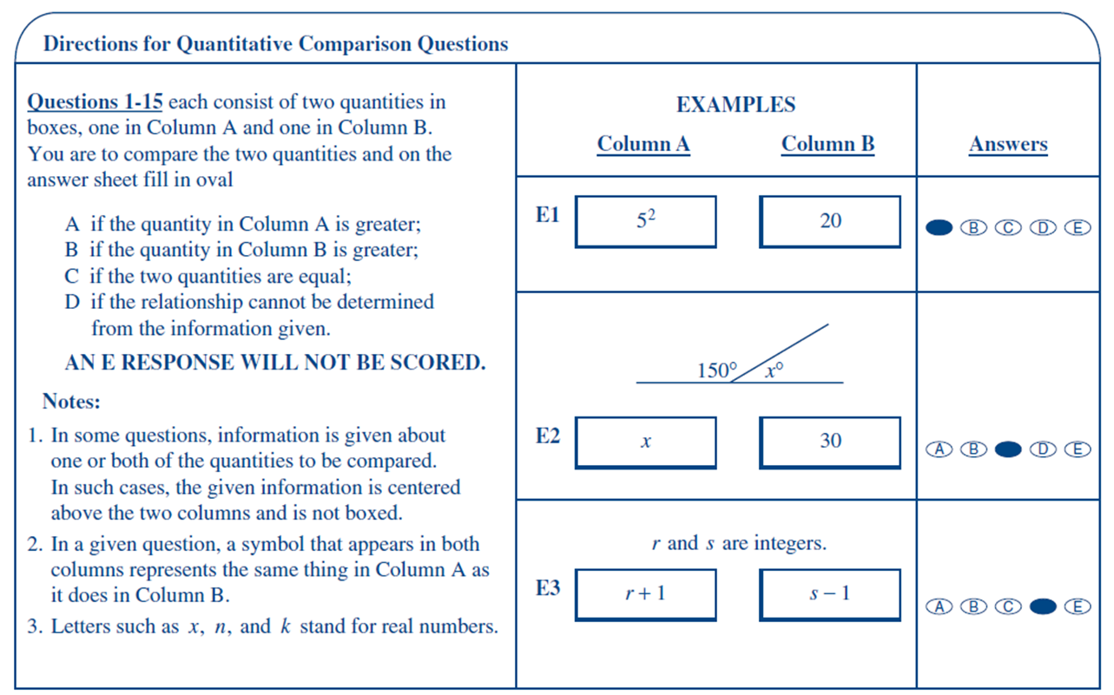

Questions 54-67

**GO ON TO THE NEXT PAGE**

**6**

**6**

**6**

**6**

**SUMMARY DIRECTIONS FOR COMPARISON QUESTIONS**

**Answer: A if the quantity in Column A is greater;**

**B if the quantity in Column B is greater;**

**C if the two quantities are equal;**

**D if the relationship cannot be determined from the information given.**

**Column A Column B**

.

The percentage of multiples of 5 that are also multiples of 2

The percentage of multiples of 2 that are also multiples of 5

The average (arithmetic mean) of four numbers is 36.

1. Asdf

The sum of those four numbers

140

*x* - *y* = 1

2*x* - 3*y*

2*y* - 3*x*

- *n* + 1

*n* + 1

**Column A Column B**

Sarah either drives her car to work or walks to work.

Sarah never drives her car to work on a sunny day.

It takes Sarah 20 minutes to walk to work and 5 minutes to drive to work.

The time that it takes Sarah to get to work on a rainy day

15 minutes

0 < *x* < 1

*x*2

*x*4

*x*4

*x*2

The retail price of a certain computer at Computer Junction is 30 percent more than its wholesale price. For a sale, the manager reduces the retail price of that computer by 25 percent.

The wholesale price of the computer

The price of the computer for the sale

**GO ON TO THE NEXT PAGE**

**6**

**6**

**6**

**6**

**SUMMARY DIRECTIONS FOR COMPARISON QUESTIONS**

**Answer: A if the quantity in Column A is greater;**

**B if the quantity in Column B is greater;**

**C if the two quantities are equal;**

**D if the relationship cannot be determined from the information given.**

**Column A Column B**

Lines *l* , *m* , and *n* lie in plane *P*.

The number of points lying on more than one line

2

Half the perimeter of a rectangle

The diagonal of the same rectangle

1. Asdf

*x* and *y* are integers. *xy* = 30.

*x* + *y*

12

Twice the area of an isosceles triangle with base of length 10

The area of an isosceles triangle with base of length 5

**STOP**

**If you finish before time is called, you may check your work on this section only. Do not turn to any other section in the test.**

**Column A Column B**

J K L M

Note: Figure not drawn to scale.

JL = KM

LM

JK

*x* is a positive even integer less than 10.

3 + *x*

8

*x* + *y* = 5

-2*y* - 2*x* = -10

*y*

*x*

SECTION 7

**Time – as long as it takes**

**13 Questions**

**7**

**7**

**7**

**7**

**Directions:** In this section solve each problem, using any available space on the page for scratchwork. Then decide which is the best of the choices given and fill in the corresponding oval on the answer sheet.

Notes:

1. All numbers used are real numbers.
2. Figures that accompany problems in this test are intended to provide information useful in solving the problems. They are drawn as accurately as possible EXCEPT when it is stated in a specific problem that the figure is not drawn to scale. All figures lie in a plane unless otherwise indicated.



SID'S CHECKING ACCOUNT

|  |  |
| --- | --- |
| Days | Change in Account Balance (in dollars) |
| Monday | +20 |
| Tuesday | -13 |
| Wednesday | -16 |
| Thursday | +9 |
| Friday | -12 |

1. The chart above shows the dollar amounts that were added to or subtracted from Sid's checking account on each of 5 days. According to the chart, the total change in Sid's account balance for all five days is equal to the change in the account balance for which single day?
   1. Friday
   2. Thursday
   3. Wednesday
   4. Tuesday
   5. Monday

SOURCES OF LANA'S COLLEGE TUITION

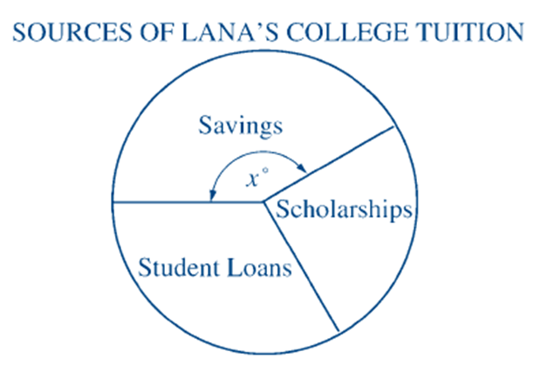

1. The pie chart above shows the three sources for Lana's college tuition. If 1/4 of the total amount was from scholarships and 1/3 was from student loans, what is the value of *x* ?
   1. 130
   2. 120
   3. 160
   4. 140
   5. 150

**GO ON TO THE NEXT PAGE**

**7**

**7**

**7**

**7**

1. If *nk* = 64 and *n* and *k* are integers, which of the following could NOT be a value of *n* ?
   1. 4
   2. 16
   3. 8
   4. 2
   5. -2
2. If 7*x* is 24 more than *x* , then *x*2 is how much more than $\sqrt{x}$?
   1. 49 - $\sqrt{7}$
   2. 24
   3. 6
   4. 2 $\sqrt{6}$
   5. 14
3. A circle of radius 4 and a circle of radius 5 have exactly one point in common. If *P* is a point on one circle and *Q* is a point on the other circle, what is the maximum possible length of segment *PQ* ?
   1. 18
   2. 14
   3. 13
   4. 10
   5. 9
4. If ( *x* + 2)*n* ( *x* - 2) = ( *x* + 2) ( *x*2 - 4) for all values of *x* , what is the value of *n* ?
   1. 4
   2. 1
   3. 3
   4. 2
   5. It cannot be determined from the information given.

*O*

*x*

*y*

(*a*, *b*)

(*c*, *d*)

(*e*, *f* )

1

1

1. The coordinates of three points are given in the figure above. Which of the following must be true?

I. *b* = *c*

II. *f* > *e*

III. *a* > *d*

* 1. None
  2. I only
  3. I and II only
  4. II and III only
  5. I, II, and III

|  |  |
| --- | --- |
| List I | List II |
| 2 | 3 |
| 4 | 5 |
| 7 | 6 |

1. One number is to be selected at random from each of the lists above. What is the probability that both of the numbers selected will be less than 5 ?
   1. 1/9
   2. 2/9
   3. 1/3
   4. 4/9
   5. 5/9

**GO ON TO THE NEXT PAGE**

**7**

**7**

**7**

**7**

1. The sum of five consecutive whole numbers is less than 25. One of the numbers is 6. Which of the following is the greatest of the consecutive numbers?
   1. 10
   2. 9
   3. 8
   4. 7
   5. 6
2. If a triangle has exactly one of its vertices on a circle, which of the following CANNOT be the number of points that the triangle and the circle have in common?
   1. Six
   2. Five
   3. Four
   4. Three
   5. Two
3. What are all possible values of *x* for which

*x*  + *x*  + *x* + *x* + *x* 5

2*x* 2

=

?

* 1. No real numbers
  2. 0 only
  3. 1 only
  4. 5/2 only
  5. All real numbers except 0

**STOP**

**If you finish before time is called, you may check your work on this section only. Do not turn to any other section in the test.**

1. If *x* = 44, what base is *x* in?
   1. 0
   2. 5
   3. 10
   4. 15
   5. 20

*n* = 1234567891011 … 787980

1. The integer *n* is formed by writing the positive integers in a row, starting with 1 and ending with 80, as shown above. Counting from the left, what is the 91st digit of *n* ?
   1. 0
   2. 1
   3. 2
   4. 3
   5. 4