“Frosty Cold Fusion
with Diet Coke”
by Catherine Chronos

Problem & Purpose

United States oil production has been dropping since 1970, leading us to be increasingly reliant on the Middle East for energy needs.
I propose to replace our nation’s dependence on fossil fuels with an alternative dark and sticky energy source that’s safer, cheaply manufactured, and really very tasty once you get used to it!
Hypothesis

Within a pressurized environment carefully-controlled for even volumetric density, thixotropic Micro-pockets of high-temperature fusion reactions within a carbonated liquid infused with aspartame and saccaharin can be steadily triggered and controlled using sonoluminescence without cascading into inconveniently large thermobaric explosions of nuclear radiation.
Procedures
Sonoluminescence as a way of creating Acoustic Inertial Confinement Fusion requires a fluid medium conducive to bubble creation.
Eschewing unreasonably exotic solutions led me to Diet Coke, which is an abundant source of gas as well as hydrogen and is easily induced to cavitate when triggered with the proper acoustic stimulus.
FLUID MEDIUM: Diet Coke! ACOUSTIC STIMULUS: “Time After Time” by Cyndi Lauper
Results

After much research into finding an effective acoustic trigger – performed alone in complete darkness in bedroom late at night, acoustics uncontaminated by any ringing from the nearby telephone, eating Häagen-Dazs straight from the container to cool the blood and increase visual acuity, vigorously rubbing eyelids to create tears to remove grit buildup that might impede viewing – tiny flashes of light were observed, indicating sonoluminescence.
Conclusions

Under proper and easily reproducible circumstances (repeated over the course of a week to verify results, shown in the Data Table), sonoluminescence can be created in a sustained environment of solitary isolation and need only be harnessed by appropriate engineering to generate electricity.
Recommendations

Scientists who are compatible with and have affinity for each other should get together and collaborate on pursuing goals like this and others for the benefit of all.
Appendix: Data Table

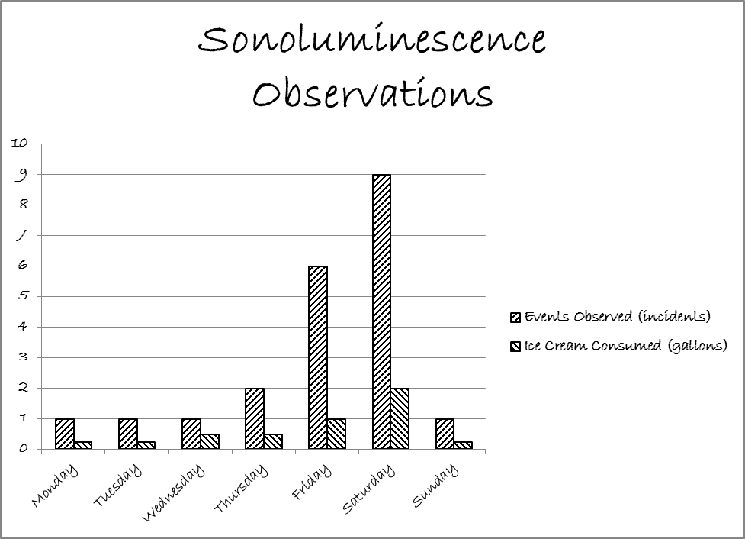

REFERENCE FORMAT:

