Cut them out and place them in proper order below and add your predictions of who will lead us into the next century!

**PRESIDENTS OF THE UNITED STATES**

From the beginning into the 21st Century!

**Millard Fillmore**

**Zachary Taylor**

#**#44**

**________________**

**_________**

**Harry S. Truman**

**Calvin Coolidge**

**James Buchanan**

**John Adams**

**Chester Alan Arthur**

**James Madison**

**#41**

**________________**

**Franklin Delano Roosevelt**

**William McKinley**

**#43**

**________________**

**#42**

**________________**

**Thomas Jefferson**

**Lyndon Baines Johnson**

**Richard Milhous Nixon**

**John Quincy Adams**

**George Washington**

**William Henry Harrison**

**Martin Van Buren**

**James Earl Carter Jr.**

**James Abram Garfield**

**Andrew Jackson**

**Grover Cleveland (Second)**

**Woodrow Wilson**

**Warren Gamaliel Harding**

**Gerald Rudolph Ford**

**John Fitzgerald Kennedy**

**John Tyler**

**William Howard Taft**

**Abraham Lincoln**

**Ulysses Simpson Grant**

**Rutherford Birchard Hayes**

**Grover Cleveland (First)**

**Herbert Clark Hoover**

**Dwight David Eisenhower**

**James Monroe**

**Ronald Wilson Reagan**

**Benjamin Harrison**

**Theodore Roosevelt**

**James Knox Polk**

**Andrew Johnson**

**Franklin Pierce**

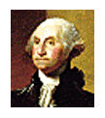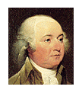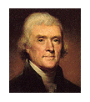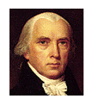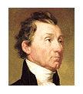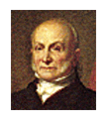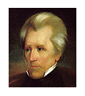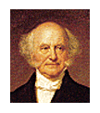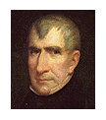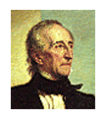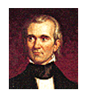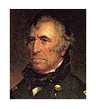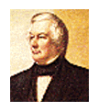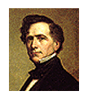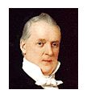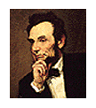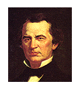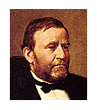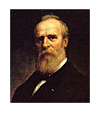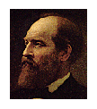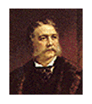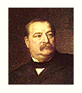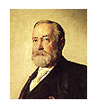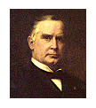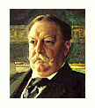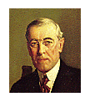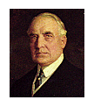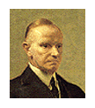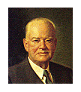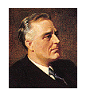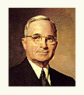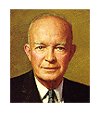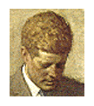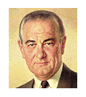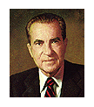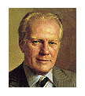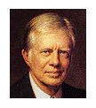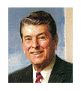

**#10**

**#20**

**#30**

**#40**

**#4**

**#9**

**#14**

**#19**

**#24**

**#29**

**#34**

**#39**

**#44**

**#3**

**#8**

**#13**

**#18**

**#23**

**#28**

**#33**

**#38**

**#43**

**#2**

**#7**

**#12**

**#17**

**#22**

**#27**

**#32**

**#37**

**#42**

**#1**

**#6**

**#11**

**#16**

**#21**

**#26**

**#31**

**#36**

**#41**

**#5**

**#15**

**#25**

**#35**